**SVKM’s NMIMS**

**Mukesh Patel School of Technology Management & Engineering**

**Department of Electronics and Telecommunication Engineering**

**Subject: Image and Video Processing Program: B.Tech/BTI/MBA**

**Sem: VII ACAY: 2020- 21**

**EXPERIMENT NO.10**

**Aim:**

1. To WAP in PYTHON to perform morphological dilation and erosion on an image
2. To write a program in PYTHON to perform morphological opening and closing on an image

**Software:** PYTHON

**Prerequisite:**

|  |  |
| --- | --- |
| Sr. No | Concepts |
| 1. | Morphological operations like dilation, erosion, opening and closing |

**Outcome:**

After successful completion of this experiment students will be able to:

1. Implement dilation, erosion, opening and closing
2. See the effect of morphological opening and closing on an image

**Theory:**

**Dilation**

Dilation is defined as follows

$$A⊕B=\{ Z|[\left({\hat{B}}_{z}\right)∩A]∈A\}$$

In the above equation, A is the image and B is the structuring element. In the above equation, $\left({\hat{B}}_{z}\right)$ means taking reflection of B about its origin and shifting it by Z. Hence dilation of A with B is set of all displacements, Z, such that $\left({\hat{B}}_{z}\right)$ and $A$ overlap by at least one element

**Erosion**

$$A⊝B=\{ Z|\left({\hat{B}}_{z}\right)∈A\}$$

This indicates that the erosion of A by B is set of all points that B, translated (shifted by Z), is a subset of A that is B is entirely contained within A. Erosion reduces the number of pixels from the object boundary.

**Opening**

Morphological opening of an image is basically erosion followed by dilation

$$A∘B=OPEN\left(A,B\right)=D(E\left(A\right))$$

**Closing**

Morphological opening of an image is basically dilation followed by erosion

$$A∙B=CLOSE\left(A,B\right)=E(D\left(A\right))$$

|  |
| --- |
| Name of the Experiment: To perform morphological operations on an image |
| Roll No. C018 Name: Dhruvit Jain |
| Program: B.Tech ExTC Semester : VII |
| Date of Performance: 18/09/2020 Date of Submission: 18/09/2020 |

**CODE:**

import numpy as np

from skimage import io

import matplotlib.pyplot as plt

from scipy.fftpack import dct,idct

from skimage.color import rgb2gray

# image1=io.imread('bubbles.tif').astype(int) #it is a boolean image

# image1= 255*image1

# image1= io.imread ('squares.tif')

image1= io.imread ('wood_disk.tif') #it is gray, so we need to turn to binary

for r in range (0,image1.shape[0]):

for c in range (0,image1.shape[1]):

if image1[r][c]>= 155:

image1[r][c]=255

else:

image1[r][c]=0

io.imshow (image1)

sh=image1.shape

row = sh[0]

col = sh[1]

im_erosion = image1.copy()

sz = 11 #size of structuring element

se = 255*(np.ones([sz,sz]))

cent = int((sz-1)/2)

#erosion

for r in range (cent,row-cent):

for c in range (cent,col-cent):

temp = image1[r-cent:r+cent+1,c-cent:c+cent+1]

if np.array_equal(temp,se):

im_erosion [r][c]=255

else:

im_erosion[r][c] = 0

im_dilation = im_erosion.copy()

for r in range (cent,row-cent):

for c in range (cent,col-cent):

temp = im_erosion[r-cent:r+cent+1,c-cent:c+cent+1]

if np.isin(255,temp):

im_dilation [r][c]=255

else:

im_dilation[r][c] = 0

plt.figure (figsize=(11,11))

plt.subplot (1,3,1)

io.imshow (image1,cmap="gray")

plt.title ("Original Image")

plt.subplot (1,3,2)

io.imshow (im_erosion,cmap="gray")

plt.title ("Eroded Image")

plt.subplot (1,3,3)

io.imshow (im_dilation,cmap="gray")

plt.title ("Dilated Image")

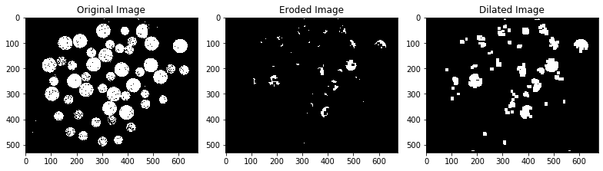

CONCLUSIONs

1. Before applying morphological operations, image should be converted to a binary image.

2. Erosion causes objects to redduce in size by half the size of structuring element in both rows and columns.

3. If eroded image is dilated, then the eroded objects regain their sizes.

4. If an object is to be removed, the size of structuring element should be greater than the object.

5. For the squares image, size of structuring element was chosen to select the larger sqquares.